Template for Author’s Abstract

Martin Novak (ORCID)¹, Hitoshi Ohmori (ORCID)²

¹Faculty of Mechanical Engineering, J. E. Purkyne University in Usti nad Labem. Pasteurova 3334/7, 400 01 Usti nad Labem. Czech Republic. E-mail: martin.novak1@ujep.cz

²Materials Fabrications Laboratory, RIKEN. 2-1 Hirosawa, 351-0198 Wako. Japan. E-mail: ohmori@mfl.ne.jp
Formal structure is directing strictly by this template and buttons of the format styles. All text is in single column format. Name of authors is in format “Name and Surname” without degrees on one row for all authors, second and next rows are for full address include email. Abstract is 8 – 12 rows and there is introduction into the problem of the article. Font of article is only Garmond – valid also for tables, pictures, graphs and others. Format of pages (borders) is set automatically in this template. Length of abstract is up to three pages. Maximum of keywords are 5. Paragraph numbering follows by the formal style. Descriptions of pictures, tables, graphs in only in English and they are included directly in to the text. Size of the pictures, tables and graphs is only in two size – 8 cm or 17 cm width. Is strictly forbidden to place two pictures, tables or graphs abreast (one picture – one row) and add additional describes in the Word editor!
Abstract files in Word format and PDF should be sent by the corresponding author to the email lenka.dobsakova@unob.cz by 28.2. 2023.
Keywords: Equation, Manufacturing Technology, Pictures, Tables, Template
- Steps for successful publishing of article
- Open this template, delete all texts, put your text of article in this template or write text in this template,
- Format each paragraph of your text by the styles buttons – top on the template, see in Fig. 1.
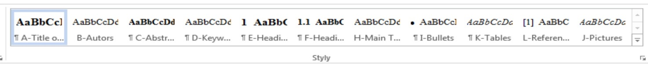
Fig. 1 Buttons of Format Styles
- Pictures, Tables, Graphs, Equations
- Pictures, tables and graphs are arrange directly in to the text, there are only width 8 or 17 cm on one row,
- All explanations in the pictures or graphs are in the English and may not be additional describes in Word,
- Text of description is – Fig. 1 Xxxx, Tab. 1 Xxxx, Graph 1 Xxxx ; Tables are describe above,
- Equations are put with centred justification of formula and right of numbering,
, (1)

Where:

c_{vt}...Constant [-],

T…Durability [min].
Acknowledgement

Acknowledgement is arrange behind results and before References without numbering.

References
- NOVAK, J., NOVOTNY, P., NOVY, K. (1990). Sample Book, pp. 58 – 68. ABC Publisher, Prague. ISBN
- NOVY, L. (1996). Sample paper. In: Sample Journal, Vol. 3, No. 1, pp. 9 – 15. TTP. Switzerland. ISSN

